Installing The SDKs:
- Install the latest platform SDK for your OS (for WinXP, install the Windows Server 2003 SDK)
- Install the DirectX SDK
- In your Visual Studio 2005, go to Tools->Options->Projects and Solutions->VC++ Directories
  - Select "Include files" in the "Show directories for:" combo-box
    - Make sure "<DirectX SDK install dir>\Include" is listed first in the list box of the dialog.
  - Select "Library files" in the "Show directories for:" combo-box
    - Make sure "<DirectX SDK install dir>\Lib\x86 is listed first in the list box of the dialog

Setting Up a New Project

- Make sure the <Platform SDK>\include and <Platform SDK>\lib directories are listed in your include/lib directories (respectively) as well.
- Add strmiids.lib to your project
- If you want to use the BaseClasses from the DirectShow samples, you will need to add its directory to the Additional Include Directories of your projects and you will need to build strmbasd.lib or strmbase.lib (for debug/release respectfully) and add it to your project.
To build the strmbas?.lib follow the procedure below:
  - In the Platform SDK's menu in your windows Start Menu, find the suitable build environment command prompt and open it (see example below)

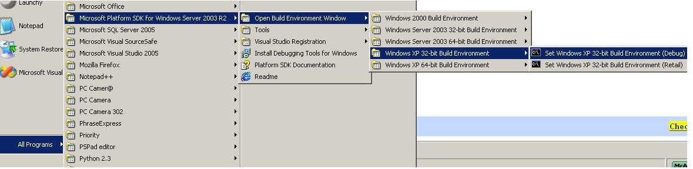

  - In the command prompt do to "<DirectX SDK install dir>\Samples\Multimedia\DirectShow\BaseClasses\" directory
  - Run the "nmake" command. (a subdirectory will be created in the "<DirectX SDK install dir>\Samples\Multimedia\DirectShow\BaseClasses\", and the library will be created in it)
  - There are some externals that strmbas?.lib refer to that can be found in winmm.lib, so add it to your project as well.
  - If there are conflicts between LIBCMTD.lib and strmbas?.lib, go to Project Properties (alt+F7)->Configuration Properties->Linker->Input and add LIBCMTD.lib to the "Ignore Specific Library" key.

Misc. Remarks
The result project output (exe/dll) might have DLL dependencies.
Use Dependency Walker to determine the dependencies and deploy them together with the exe or dll.

